**Vidyavardhaka College of Engineering**

**Autonomous Institute, Affiliated to Visveswaraya Technological University, Belagavi. Accredited by NBA, New Delhi (2017-18 to 2019-20) & NAAC with ‘A’ Grade**

**Gokulam 3rd Stage, Mysuru - 570002, Karnataka, India**



#### **A Project Report on**

**“SMART BRIDGE USING AURDINO”**

#### **Submitted by**

**Souparnika S [4VV21EC149]**

**Suhas D D [4VV21EC158]**

**Dhanushree B [4VV21IS033]**

**Ankit Timmapur [4VV21IS015]**

**Harish Gowda H R [4VV21AI016]**

**Chandana M [4VV21CI015]**

**Under the Guidance of**

**Guide Name : Sharmila A**

**Designation: Assistant Professor**

**Department: Civil Engineering, VVCE, Mysuru.**



**Engineering Exploration Lab [21AE27]**

**2021-2022**

**ACKNOWLEDGEMENT**

We take this opportunity to acknowledge our profound gratitude to **Dr. B Sadashive Gowda,** Principal, Vidyavardhaka college of Engineering, Mysuru for all the Infrastructure and facilities provided during our study in the institution.

We would like to place on record of our deep sense of gratitude to our project guide **Sharmila A, Assistant Professor, Department of civil engineering** ,Vidyavardhaka college of Engineering, Mysuru for her valuable guidance, help and useful suggestions in this project.

We express our sincere gratitude to the Teaching and non-teaching staff, friends and classmates who helped us directly or indirectly for the successful completion of the project.

Finally, we would like to thank our Parents and all our beloved ones for supporting us in many ways that meant.

**Souparnika S [4VV21EC149]**

**Suhas D D [4VV21EC158]**

**Dhanushree B [4VV21IS033]**

**Ankit Timmapur [4VV21IS015]**

**Harish Gowda H R [4VV21AI016]**

**Chandana M [4VV21CI015]**

**TABLE OF CONTENTS**

| **Sl. No.** | **Contents** | **Page No.** |
| --- | --- | --- |
| 1 | Acknowledgement | 2 |
| 2 | Table of contents | 3 |
| 3 | Abstract | 3-4 |
| 4 | Introduction | 5 |
| 5 | Components required | 6-7 |
| 6 | List of figures | 8 |
| 7 | Methodology | 9-10 |
| 8 | Workflow | 11 |
| 9 | Advantage and Disadvantages | 12-13 |
| 10 | Applications | 13 |
| 11 | Conclusion | 14 |
| 12 | Reference | 15 |

**ABSTRACT**

Due to the climate change and global warming, risks associated with floods impose greater damages to infrastructure projects especially in case of bridges. Destruction to these projects impacts local community and overall economy of the country. So, the overall goal of this project is to propose a design of bridge that will resist every kind of flood. Unfortunately, if a bridge gets affected due to flood, the aim also includes to provide mitigation measures.

Our model offers solution in two parts. namely:

Part-1: Incrementing the height of the bridge to prevent flooding of the bridge and overflow of water on the bridge.

Part-2: Restricting the movement automatically at one end when flood occurs and thus making commutators aware of the scenario.

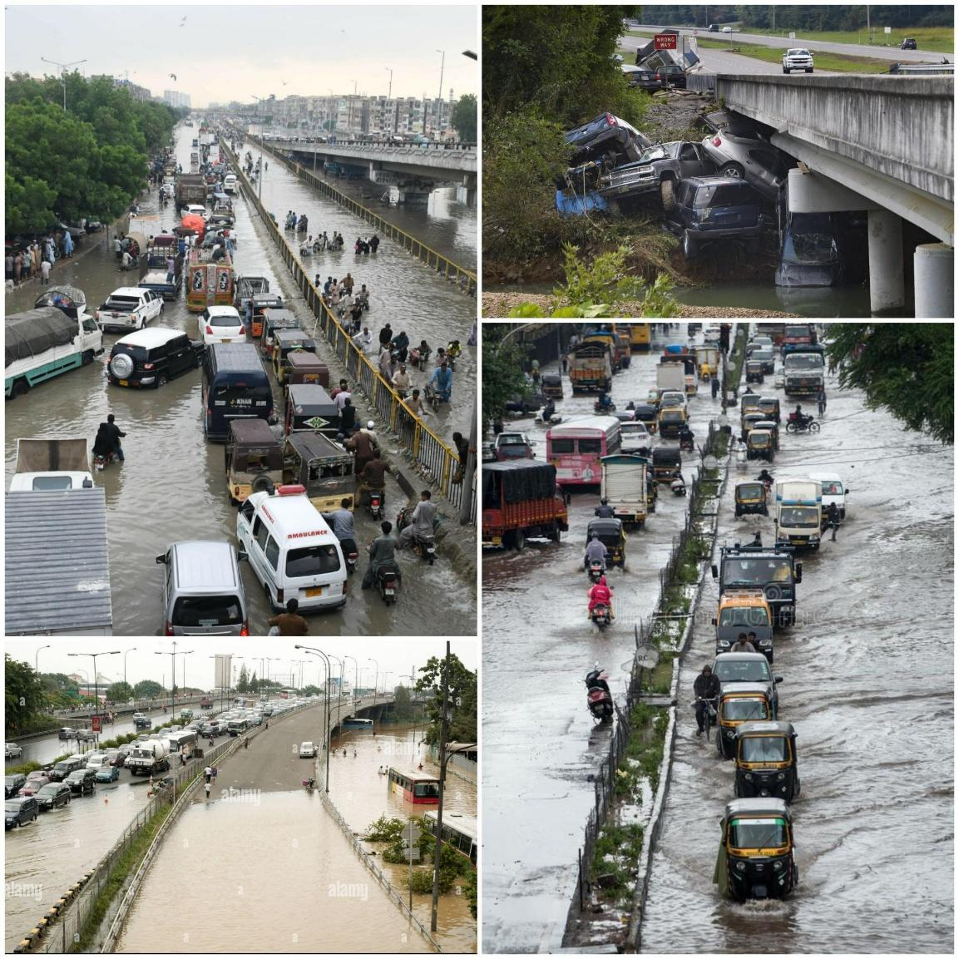

**\*\*\*\***

**INTRODUCTION**

During extreme rainy days , water level at the dams increases which leads to the overflow of water on the bridges constructed over the dam .This gives rise to various issues .

Some of the major issues are as follows :

1. The bridge gets flooded with extreme water.

2. People will not be able to cross the river.

3. Many other activities like Travelling, Transportation of goods via the bridge and etc would be stopped.

4. If the bridge is constructed from a Higher embankment region –lower embankment region or vice versa, the lower side region would be flooded which restricts movements and giving rise to traffic at the higher region.

Once such recently happened case was in Karnataka where 10 districts were flooded by Krishna river Spurt .

In order to overcome with this ,we came up with the idea of constructing a smart bridge which has a solution for all these issues .

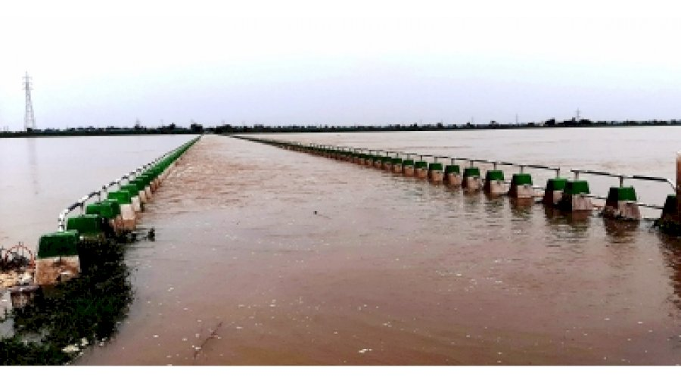

Flooding by the krishna river spurt .

**COMPONENTS REQUIRED**

The following components were required to construct the smart bridge :

1.**Arduino UNO and Arduino cable .**

The Arduino UNO board is a micro-controller, mostly used in electronics project and to do programming in this board via the Arduino cable. The board has regular innovation and a bug fix in the design of the board to make the board suitable for the project’s use.

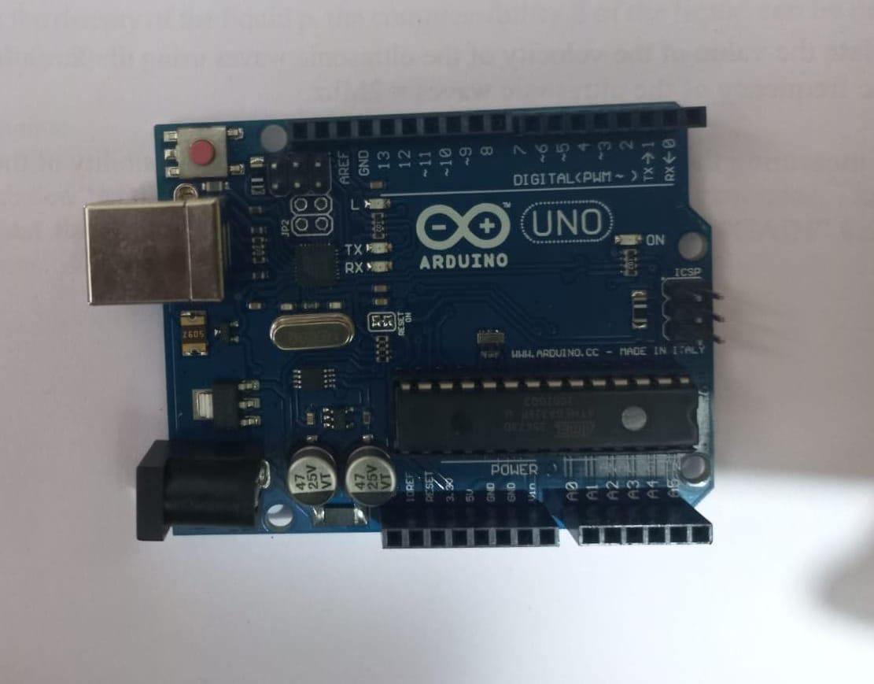

**2.Servo motors.**

Servo motor are used to perform a certain mechanical output as instructed by the micro-controller**.**

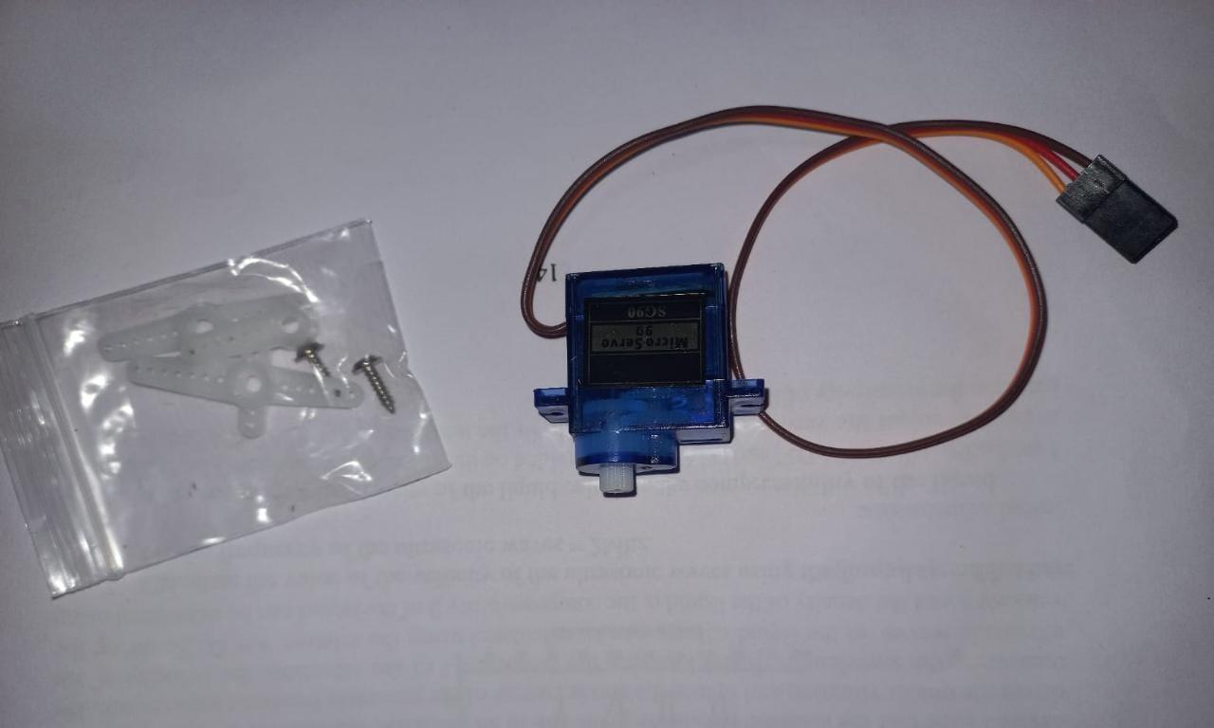

**3.Moisture sensors**

Moisture sensors are used to detect/sense the water content ,water level and are designed to send the information to the controllers.

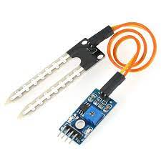

**4. Small breadboard.**

Breadboard is used for building temporary circuits. It is useful to the person who wants to build a circuit to demonstrate its action.

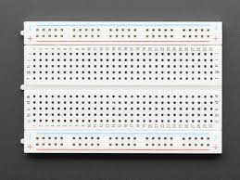

**5. Connecting wires.**

Connecting wires are ued to connect two electronic components making it a complete circuit.

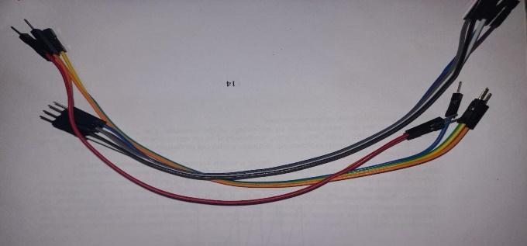

**6. Batteries .**

Batteries provide power for the circuit components to function.

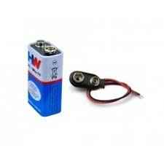

**LIST OF FIGURES**

| **PARTICULARS** | **QUANTITY** | **COST** |
| --- | --- | --- |
| **1. Aurdino UNO Board and Aurdino Cable .** | **1** | **800** |
| **2. Servo Motors** | **2** | **150X 2=300** |
| **3. Moisture Sensors** | **2** | **130x2=260** |
| **4.Breadboard** | **1** | **30** |
| **5. Batteries** | **2** | **2X20=40** |
| **6. Thick cardboard and other extra materials** | **Lumpsum** | **150** |
| **7. Connecting wires** | **Lumpsum** | **50** |

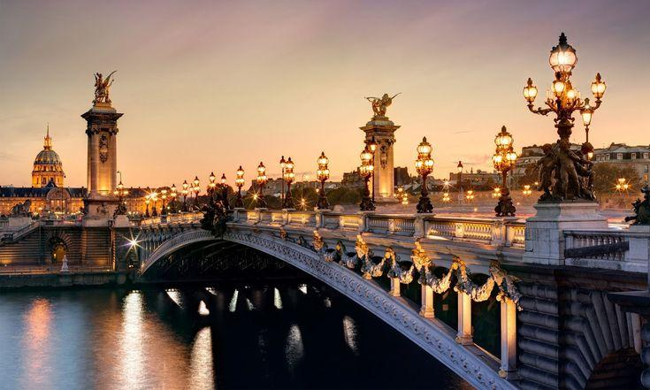

**METHODOLOGY**

**Part -1 : Increementing the bridge height to avoid flooding of the bridge** .

Once the moisture sensor which is attached underneath the bridge, detects water and the rise in water level in the dam ,passes the information to the microcontroller Aurdino UNO board . It contains a set of predefined instructions which is programmed into it.

It is further connected to servo motors which upon receiving the instructions from the microcontroller raises the level of the bridge by steps accordingly.

The height of the bridge is altered according to the instructions passed by the microcontroller which operates on the basis of information passed by the moisture sensors.

The height of the bridge automatically decreases as soon the moisture sensors detects the decrement in the water level under the bridge.

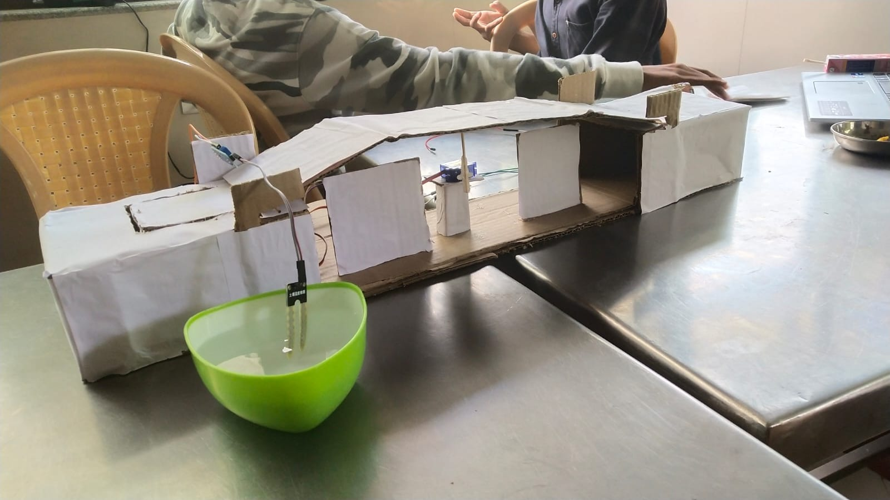

**Part-2 :Automatic Movement Restrictor**

There will be another moisture sensor attached at the lower embankment area of the bridge which detects the rise in water level and passes the information to the microcontroller Aurdino uno which in turn, instructs the servo motor to release the barricade for the restriction of movement at the Higher embankment area .

This also makes the commutators at the higher embankment region aware of the flooding scenario taking place at the lower embankment region.

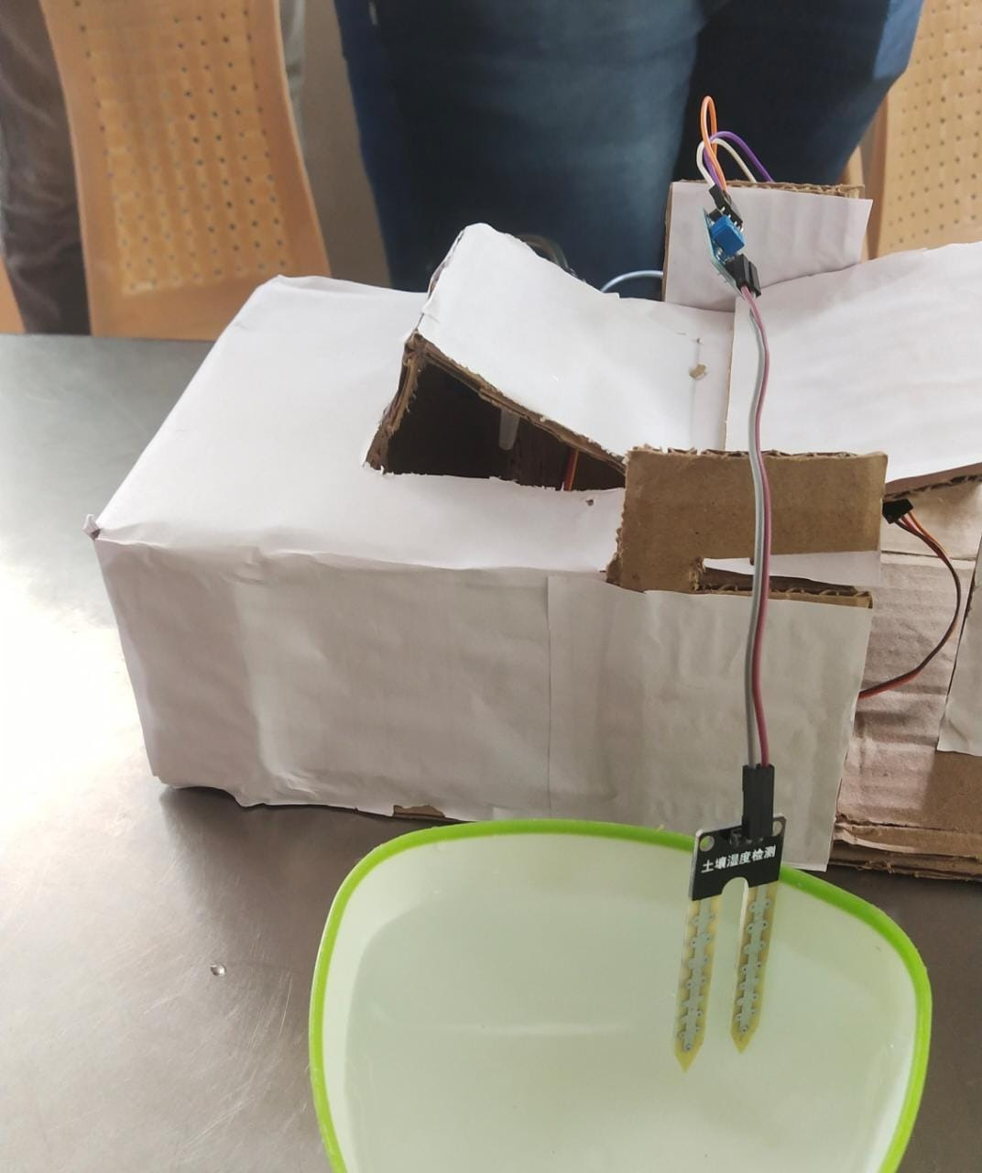

**Circuit Diagram and AURDINO Code**

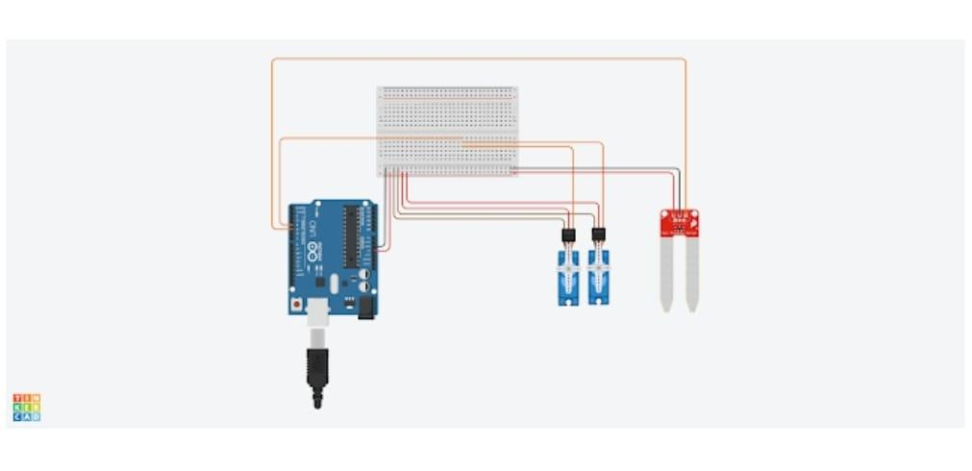

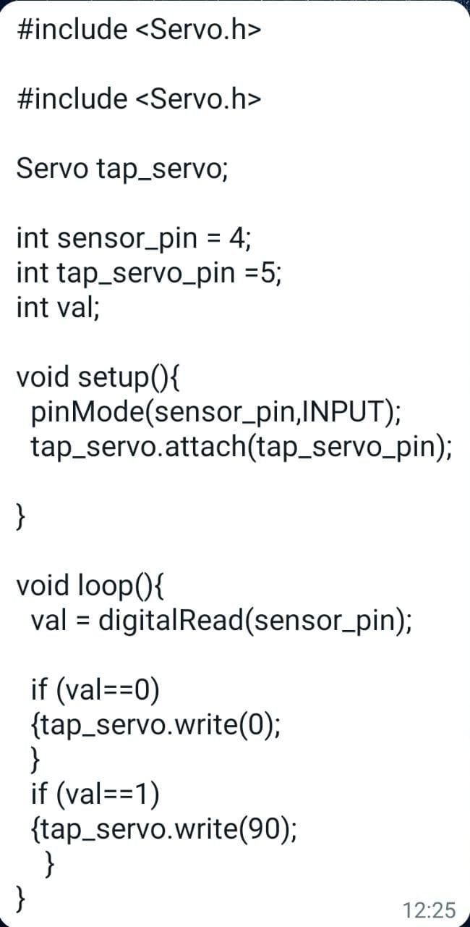

**WORK FLOW OF THE SYSTEM**







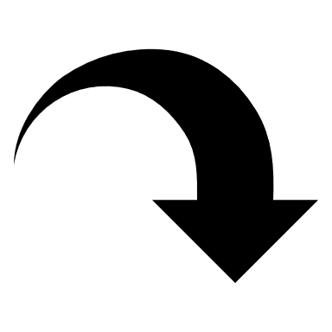

**ADVANTAGES AND DISADVANTAGES**

| **ADVANTAGGES** | **DISADVANTAGES** |
| --- | --- |
| 1. Facilitates Transportation . | 1. Lot of power consumed for lifting the bridge . |
| 2. Avoids overflow of water on the bridge. | 2. Electrical malfunctioning may occur . |
| 3. Provides safety for people on the bridge from drowning also prevents flooding . | 3. High Maintainance and high cost. |
| 4.Prevents the dam from Collapsing due to high pressure. | 4. Requires regular structural integrity test. |

**Major PROS include:**

* improved journey times.
* improved air quality from reducing air pollution generated by slow-moving traffic.
* reduced delays to public transport.
* traffic speed control.
* protection of historic and environmentally-sensitive areas.

**CONS:**

* Expensive.
* Not practical for all roads
* Less or no effect beyond the flood limits
* Are subject to vandalism.
* Require regular maintenance.

**APPLICATIONS**

1.Can be implemented in high flood prone areas like :ganga basin, indo-gangatic Brahmaputra plains ,etc.

2.Can also be implemented in more avalanche prone areas like Ladakh, kullu-spiti valleys etc where there is a frequent snow slide and which gets melted into water ,leading to increase in the water levels in the reservoirs.

3. Can be used at small dams with less water-holding capacities.

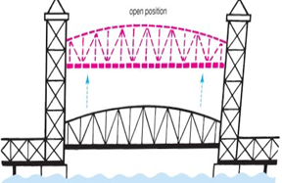

**CONCLUSION**

We being the responsible youth of our nation, would try our best to find solutions for the several existing problems in our society.

One such problem was the bridges getting flooded and collapsed due to excessive water which obstructs transportation.

We believe that we gave our best in constructing a small, smart bridge which would solve a pretty good number of issues and help in building a sustainable ,damageless environment for ourselves and also for the further generation.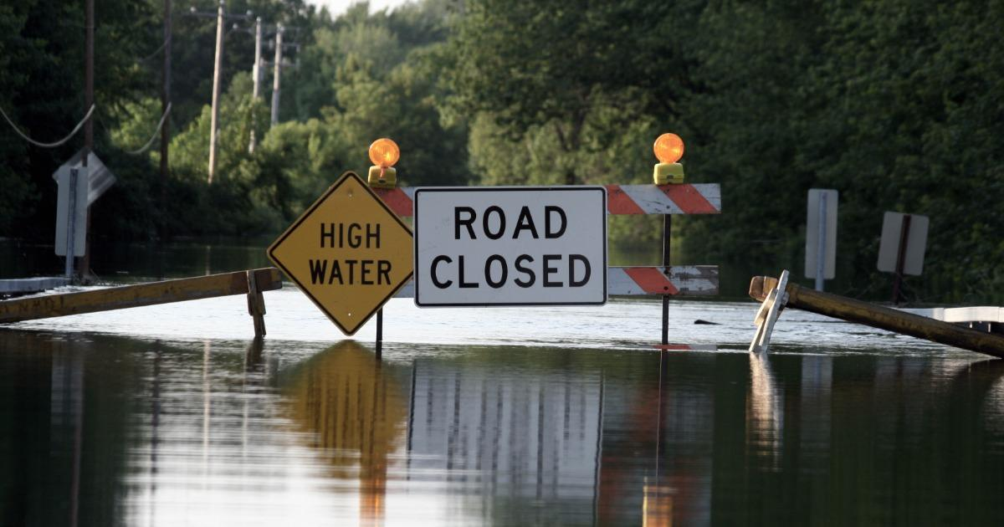

**REFERENCES**

The following are our reference sources:

<https://youtu.be/c-Zxa_dV7nk>

<https://youtu.be/2-zsQix2Ay0>

<https://youtu.be/66BicqTuEGM>



***************